Fracture Simulation of Concrete with ASR and DEF Expansion by RBSM

YUSHI MENG*, JIRADILOK PUNYAWUT†, KOJI MATSUMOTO††, KOHEI
NAGAI††† AND SHINGO ASAMOTO ††††
* University of Tokyo
4-6-1 Komaba Meguro-Ku, Tokyo 153-8505, Japan
e-mail: yushi@iis.u-tokyo.ac.jp
† University of Tokyo
4-6-1 Komaba Meguro-Ku, Tokyo 153-8505, Japan
e-mail: punyawut_jiradilok@outlook.co.th
†† University of Tokyo
4-6-1 Komaba Meguro-Ku, Tokyo 153-8505, Japan
e-mail: km312@iis.u-tokyo.ac.jp
††† University of Tokyo
4-6-1 Komaba Meguro-Ku, Tokyo 153-8505, Japan
e-mail: nagai325@iis.u-tokyo.ac.jp
†††† Saitama University
2-5-5 Shimookubo, Sakura Ward, Saitama, Saitama Prefecture 338-8570
e-mail: asamoto@mail.saitama-u.ac.jp

Key words: ASR, DEF, RBSM, Expansion, Fracture
Abstract: In this investigation, mechanical behaviors affected by two main expansion causes: Alkali-silica reaction (ASR) and Delayed ettringite formation (DEF), are predicted by the three-dimensional Rigid Body Spring Model (RBSM). By dissection concrete into 2~3mm randomized polynomial elements and analysis the forces between elements through spring connecting them, RBSM is specially a good solution for fracture analyses. ASR and DEF simulation is carried out for both separative and combinative cases. For DEF, initial expansion strain is applied among mortar elements, to reflect the expansion caused by high temperature during curing, which is more concentrated in the inner part where mortar elements experienced higher curing temperature. While in the case of ASR, the expansion strain is applied at the mortar-aggregate interfaces, to reflect the alkali silicate gel formation in and around the aggregates. This is an exclusive approach to discuss the combination of the effect of these two common causes of concrete expansion in long-term, which is difficult to be analyzed using traditional experiment due to its long experiment term required and complexity of quantitatively determinate the contribution of each expansion cause.
In the simulation, cracking patterns due to ASR and DEF are well presented. Especially in DEF case, cracks are more localized with expansion given more concentrated in the inner part. Crack patterns caused by combinations of ASR and DEF are also well reproduced by the simulations. Also, residual compressive strength after expansion, which is critical to quantitively evaluate remain structural performances, is also investigated by fracture simulation under loadings.

1 INTRODUCTION

Concrete structures do suffer from many kinds of deterioration. Among them, Alkali-silica reaction (ASR) and Delayed Ettringite Formation (DEF) are two very common and important expansion processes seen on concrete structures. With similar surface cracking pattern, it is difficult to identify and analyze the expansion reasons and their contribution to mechanical properties losses caused by ASR and DEF expansion.

Numerical simulation at mesoscale here can be a beneficial tool in understanding the inner stress and inner crack condition due to different expansion reason. In this study, the three-dimensional rigid body spring model (3D RBSM) is introduced for this purpose. Mortar is modified using 3D elements in with size around 2mm and sphere shape of aggregates also modeled directly. It has been confirmed by our research group that the 3D RBSM is a proper solution in quantitatively evaluate the concrete behavior and mechanical properties.

Thus, the object of this research is to investigate the concrete expansion behavior and residual mechanical properties due to ASR and DEF using numerical simulation.

2 Method of Numerical Analysis

In this study, 3D RBSM is introduced in simulation, which is proposed by Kawai et al(ref). A three-dimensional concrete model is formed from rigid body meshes.

To prevent cracking propagation in arbitrary directions, here Voronoi diagram is introduced in meshing, as the propagation of cracks in concrete is one of the most important factors affecting the behavior of concrete.

As illustrated in Fig.xx, to represent concrete, two types of elements are used, which are the aggregate elements and the mortar elements.

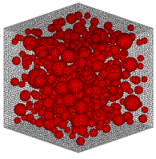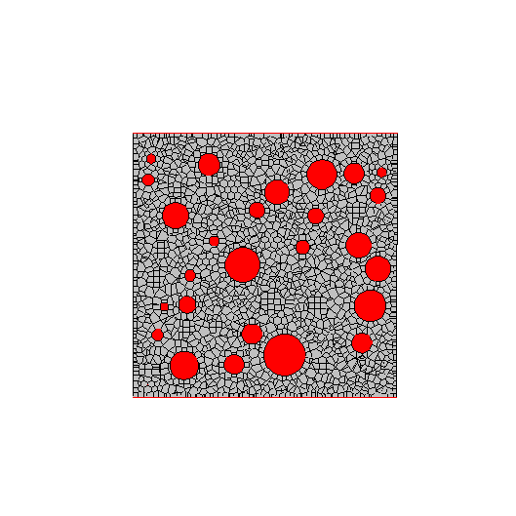

As illustrated in Fig.xx, for each rigid body mesh element, there are six degrees of freedom, including three translational degrees of freedom and three rotational degrees of freedom, at a certain point located in its interior. Each rigid body element is connected to its neighborhood by three springs, where two of them are shear springs and one is normal spring.

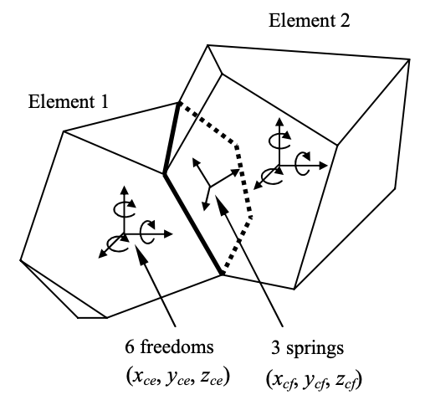

2.1 CONSTITUTIVE MODEL

A constitutive model for concrete at the mesoscale is used in this research.

The constitutive model of normal springs is shown in Fig.xx. Here the w_max is chosen to be 0.03mm, which represents a relatively more brittle behavior comparing to the general macro scale concrete model.

Linear unloading and reloading paths go through the origin are set for tension zone.

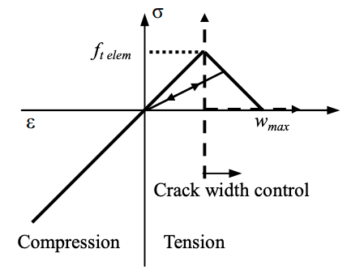

For shear springs, as illustrated in Fig.xx, an elastoplastic model is applied, where normal springs are not fractured. Shear strains and its principal directions are calculated from the resultant value of strains in two springs are updated in each step. Effect of changing in principle shear direction is not considered here for simplicity.

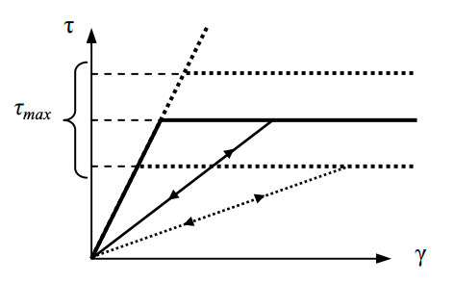

The changing of tau_max value depends on the condition of the normal spring and the tensile strength, given as Fig.xx.

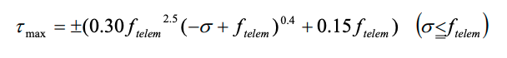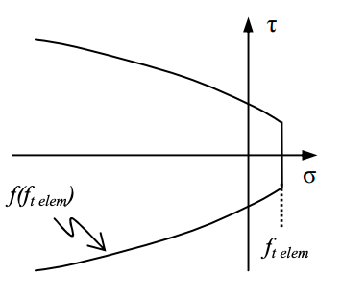

After cracking or tension fracture occurred in normal springs, the calculated shear stress also reduced. The shear spring will not be able to carry any stress when the crack width in the normal spring reached w_max.

While after shear stress reached its criterions, the stresses will only transfer through over-wrapped parts of the boundary faces between adjacent elements. For simplicity, this area is calculated using circular face equivalent.

For interfaces between mortar and aggregate elements, spring stiffnesses k_n and k_s are given by weighted average according to their perpendiculars.

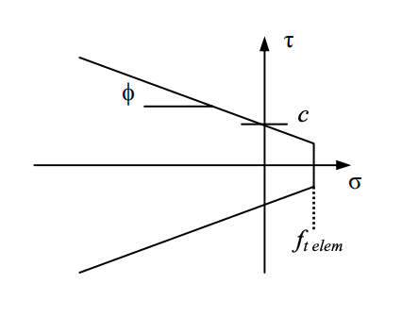

Elastoplastic model as shown in Fig.xx is applied for shear springs, where the tau_max criterion is set in Eq.xx,

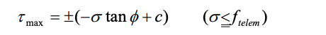

where fi and c are constant values.

2.2 NUMERICAL MODEL

Fig. ? shows one of the analyzed numerical models. The size of the model is 100 x 100 x 100 mm. Aggregate size distribution is determined according to the JSCE Standard Specification for Concrete Structures. Maximum aggregate size is 20 mm.

Pic. 100x100x100 model + agg 30%.

Aggregate volume ratio which targeted as 30% and actually reached 28% in the simulation model in use. Aggregate volume ratio which targeted as 15% and actually reached 14% in the simulation model in use.

8 cases are simulated in this research, which are listed in Table 1.
Table 1: Example of the construction of one table

The expansion is in concrete is applied by introducing the concept of expansion strain (Matsumoto et al[ref]).
Case | Aggregate Percentage | Dimension | Parameter
ASRA30P25 | Target: 30%  Actual: 28% | 100 x 100 x 100 mm | Build for ASR expansion. 25% of coarse aggregate are ASR reactive.
ASRA30P75 | Target: 30%  Actual: 28% | 100 x 100 x 100 mm | Build for ASR expansion. 75% of coarse aggregate are ASR reactive.
ASRA15P75 | Target: 15%  Actual: 14% | 100 x 100 x 100 mm | Build for ASR expansion. 75% of coarse aggregate are ASR reactive.
DEFA30I100 | Target: 30%  Actual: 28% | 100 x 100 x 100 mm | Build for DEF expansion. All mortar elements uniformly expand.
DEFA30I75 | Target: 30%  Actual: 28% | 100 x 100 x 100 mm | Build for DEF expansion. Expansion of mortar elements located in center 75 x 75 x 75 mm is intensified.
DEFA30I50 | Target: 30%  Actual: 28% | 100 x 100 x 100 mm | Build for DEF expansion. Expansion of mortar elements located in center 50 x 50 x 50 mm is intensified.
DEFA15I50 | Target: 15%  Actual: 14% | 100 x 100 x 100 mm | Build for DEF expansion. Expansion of mortar elements located in center 50 x 50 x 50 mm is intensified.

Mortar |  |  | Aggregate | Interface
Modulus of Elasticity | Tensile Strength | Compressive Strength | Modulus of Elasticity | Tensile Strength

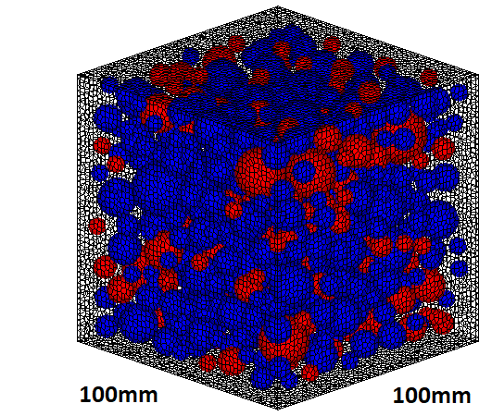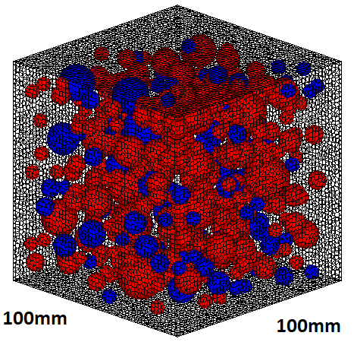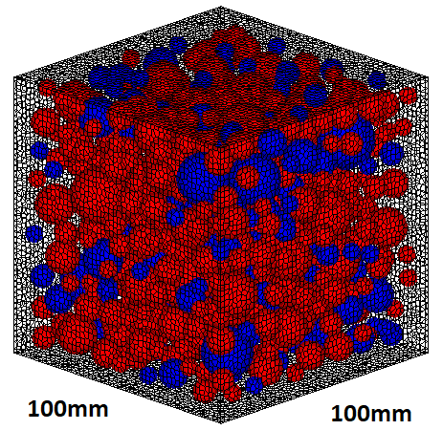

For ASR, to represent the expansion generated originally from the interface between aggregate and paste, the initial strain is introduced at the interfaces between aggregate elements and paste elements.

Four numerical models named by ASRA30P25, ASRA30P75, ASRA15P25, and ASRA15P75, are considered. A30 here means that aggregate ratio is targeted at 30%, while A15 means the aggregate ratio is targeted as 15%. P75 here represent that 75% randomly selected aggregates introduced is ASR reactive, while P25 indicate that 25% randomly selected aggregates are ASR reactive.

For DEF, to represent the paste expansion, the initial strain is introduced at the interfaces between paste and paste elements.

Four numerical models named DEFA30I100, DEFA30I75, DEFA30I50, and DEFA15I50, are considered. Same as in ASR cases, A30 here means that aggregate ratio is targeted at 30%, while A15 means the aggregate ratio is targeted as 15%. I100 indicate that center 100 x 100 x 100 mm part is given intensified expanded (whole paste part expansion), I50 indicate the center 50 x 50 x 50 mm part is given intensified expansion.

3 Simulation of Cracking pattern due to ASR and DEF Expanded Concrete

3.1 Surface Cracks

3.2 Internal Cracks and Stress

5 Simulation of Mechanical properties due to ASR and Def expansion

5.1 Residual Compressive Strength

5.2 Residual Elastic Modulus

5.3 Internal Stress Development Under Loading

6 Discussion and conclusions

REFERENCES
[1] Van Mier, J.G.M., 1997. Fracture Processes of Concrete. CRC Press.

[2] Yu, R.C. and Ruiz, G., 2006. Explicit finite element modeling of static crack propagation in reinforced concrete. Int. J. Fract. 141:357-72.

